Employee Management Dashboard
Code:
<!DOCTYPE html>
<html lang="en">
<head>
<meta charset="UTF-8" />
<meta name="viewport" content="width=device-width, initial-scale=1.0"/>
<title>Employee Management Dashboard</title>

<style>
/* ---------- RESET ---------- */
* {
margin: 0;
padding: 0;
box-sizing: border-box;
font-family: "Segoe UI", Tahoma, sans-serif;
}

body {
background-color: #f4f6f9;
color: #333;
}

/* ---------- HEADER ---------- */
header {
position: sticky;
top: 0;
background: #1f2933;
color: #fff;
padding: 15px 40px;
display: flex;
justify-content: space-between;
align-items: center;
z-index: 100;
}

header h1 {
font-size: 20px;
font-weight: 600;
}

nav a {
color: #fff;
margin-left: 25px;
text-decoration: none;
font-weight: 500;
}

nav a:hover {
text-decoration: underline;
}

/* ---------- MAIN LAYOUT ---------- */
main {
padding: 40px;
max-width: 1200px;
margin: auto;
}

/* ---------- DASHBOARD CARDS ---------- */
.dashboard {
display: grid;
grid-template-columns: repeat(auto-fit, minmax(220px, 1fr));
gap: 20px;
margin-bottom: 40px;
}

.card {
background: #fff;
border-radius: 8px;
padding: 20px;
box-shadow: 0 4px 10px rgba(0,0,0,0.08);
}

.card h3 {
font-size: 14px;
color: #6b7280;
margin-bottom: 10px;
}

.card p {
font-size: 22px;
font-weight: 600;
}

/* ---------- FORM CARD ---------- */
.form-card {
margin-bottom: 40px;
}

.form-group {
display: flex;
flex-direction: column;
margin-bottom: 15px;
}

label {
font-size: 14px;
margin-bottom: 5px;
}

input {
padding: 10px;
border-radius: 6px;
border: 1px solid #ccc;
font-size: 14px;
}

input:focus {
outline: none;
border-color: #2563eb;
box-shadow: 0 0 0 2px rgba(37, 99, 235, 0.2);
}

button {
margin-top: 10px;
padding: 12px;
background: #2563eb;
color: #fff;
border: none;
border-radius: 6px;
font-size: 14px;
cursor: pointer;
}

button:hover {
background: #1e40af;
}

/* ---------- TABLE ---------- */
.table-card {
overflow-x: auto;
}

table {
width: 100%;
border-collapse: collapse;
min-width: 600px;
}

th, td {
padding: 12px;
text-align: left;
border-bottom: 1px solid #e5e7eb;
}

th {
background: #f9fafb;
font-size: 14px;
color: #374151;
}

tr:hover {
background-color: #f3f4f6;
}

.action-btn {
padding: 6px 10px;
border-radius: 4px;
font-size: 12px;
border: none;
cursor: pointer;
}

.edit-btn {
background: #facc15;
margin-right: 5px;
}

.delete-btn {
background: #ef4444;
color: #fff;
}

/* ---------- RESPONSIVE ---------- */
@media (max-width: 768px) {
main {
padding: 20px;
}
}
</style>
</head>
<body>

<!-- HEADER -->
<header>
<h1>Empliz Dashboard</h1>
<nav>
<a href="#">Dashboard</a>
<a href="#">Employees</a>
<a href="#">Logout</a>
</nav>
</header>

<!-- MAIN -->
<main>

<!-- DASHBOARD CARDS -->
<section class="dashboard">
<div class="card">
<h3>Total Employees</h3>
<p id="totalEmployees">0</p>
</div>
<div class="card">
<h3>Total Salary</h3>
<p id="totalSalary">₹0</p>
</div>
<div class="card">
<h3>Highest Salary</h3>
<p id="highestSalary">₹0</p>
</div>
</section>

<!-- FORM -->
<section class="card form-card">
<h2 style="margin-bottom: 15px;">Add Employee</h2>

<div class="form-group">
<label>Employee Name</label>
<input type="text" id="nameInput" />
</div>

<div class="form-group">
<label>Department</label>
<input type="text" id="deptInput" />
</div>

<div class="form-group">
<label>Salary</label>
<input type="number" id="salaryInput" />
</div>

<button id="addBtn">Add Employee</button>
</section>

<!-- TABLE -->
<section class="card table-card">
<h2 style="margin-bottom: 15px;">Employee List</h2>

<table>
<thead>
<tr>
<th>Name</th>
<th>Department</th>
<th>Salary</th>
<th>Action</th>
</tr>
</thead>
<tbody id="employeeTable"></tbody>
</table>
</section>

</main>

<script>
const employees = [];
let editIndex = null;

const nameInput = document.getElementById("nameInput");
const deptInput = document.getElementById("deptInput");
const salaryInput = document.getElementById("salaryInput");
const tableBody = document.getElementById("employeeTable");

const totalEmployeesEl = document.getElementById("totalEmployees");
const totalSalaryEl = document.getElementById("totalSalary");
const highestSalaryEl = document.getElementById("highestSalary");

document.getElementById("addBtn").addEventListener("click", addEmployee);

function addEmployee() {
const name = nameInput.value.trim();
const dept = deptInput.value.trim();
const salary = Number(salaryInput.value);

if (!name || !dept || !salary) return;

if (editIndex === null) {
employees.push({ name, dept, salary });
} else {
employees[editIndex] = { name, dept, salary };
editIndex = null;
document.getElementById("addBtn").innerText = "Add Employee";
}

clearForm();
renderEmployees();
updateDashboard();
}

function renderEmployees() {
tableBody.innerHTML = "";

employees.forEach((emp, index) => {
const row = document.createElement("tr");

row.innerHTML = `
<td>${emp.name}</td>
<td>${emp.dept}</td>
<td>₹${emp.salary}</td>
<td>
<button class="action-btn edit-btn">Edit</button>
<button class="action-btn delete-btn">Delete</button>
</td>
`;

row.querySelector(".edit-btn").addEventListener("click", () => editEmployee(index));
row.querySelector(".delete-btn").addEventListener("click", () => deleteEmployee(index));

tableBody.appendChild(row);
});
}

function editEmployee(index) {
const emp = employees[index];
nameInput.value = emp.name;
deptInput.value = emp.dept;
salaryInput.value = emp.salary;
editIndex = index;
document.getElementById("addBtn").innerText = "Update Employee";
}

function deleteEmployee(index) {
employees.splice(index, 1);
renderEmployees();
updateDashboard();
}

function updateDashboard() {
totalEmployeesEl.innerText = employees.length;

const salaries = employees.map(e => e.salary);
const totalSalary = salaries.reduce((a, b) => a + b, 0);
const highestSalary = salaries.length ? Math.max(...salaries) : 0;

totalSalaryEl.innerText = `₹${totalSalary}`;
highestSalaryEl.innerText = `₹${highestSalary}`;
}

function clearForm() {
nameInput.value = "";
deptInput.value = "";
salaryInput.value = "";
}
</script>

</body>
</html>

Summary:
I developed The Employee Management Dashboard by using html,css and java Script.
In Html I used sections for dividing my content ,nav for navbar,table elements like td,th,tr and all.coming to css I used like basic styles like padding,flex like that and coming to javascript I used functions,getElementById,addEvevntListeners,querySelector and I had done fetching,updating and also deleting operations also
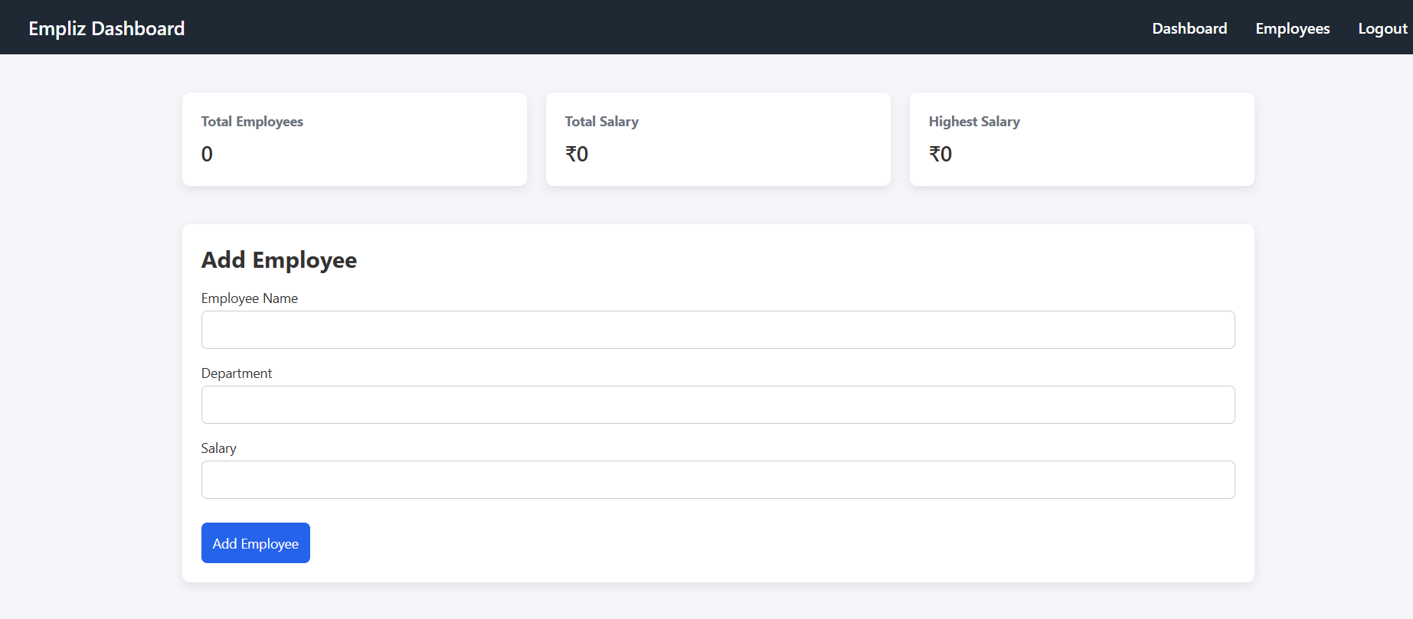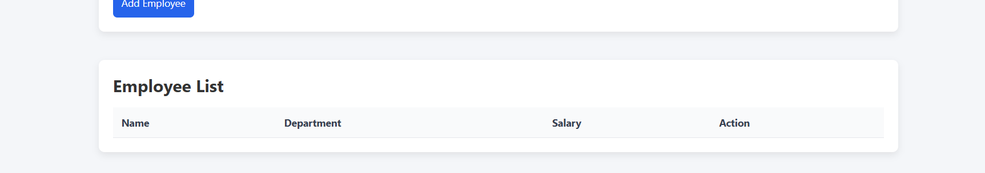
These are the outputs before entering the data
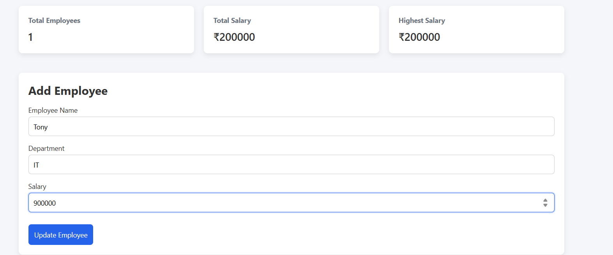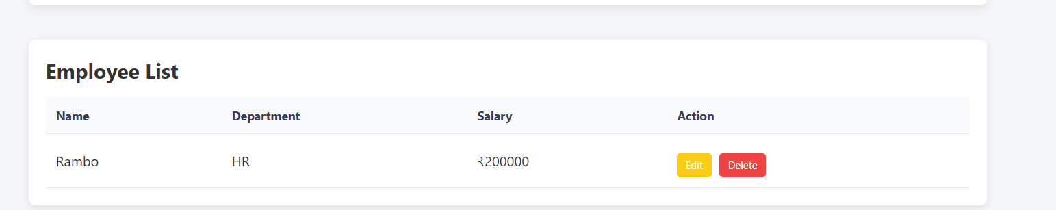
These are the outputs after entering The Data.We can Do Edit and Delete operations Also

